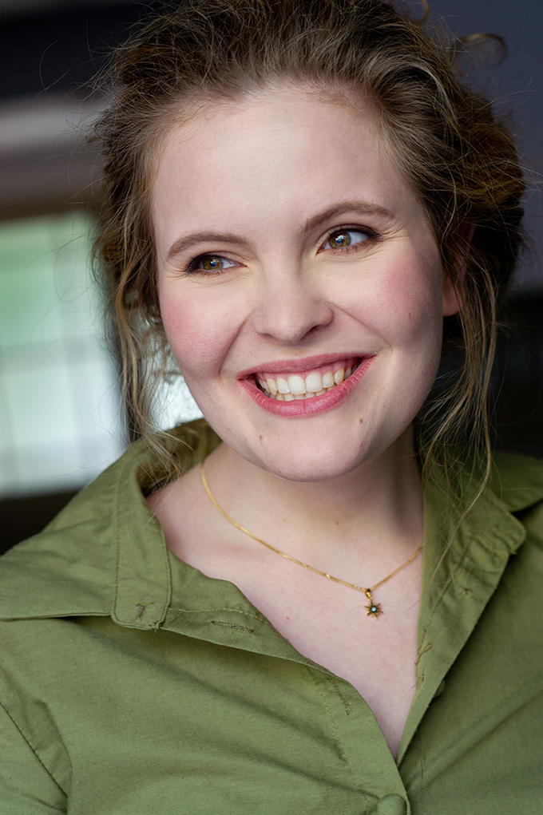
J u l i a J a m i e S p a r r o w

also known as Julia R. A. Bardarsky

Actress

Berlin | Certified
JBarroe@outlook.de
Alternat. cast@juliasparrow.com
www.juliasparrow.com

Currently located in Berlin
Fluent in English & German

« Appearance »
Central European, White
Hair » Blonde, Curly, Long
Eye Colour » Green-Brown
Height » 172,3 cm

« Content »
Personal Information
Appearance
Appearance in Film, TV & Theatre
Voice Acting
Voice Details
Education & Further Trainings & Studies

Appearing in

« Film »
{Selection, starting most recent}

2023
A Request for Citizenship – Careen
Directed by Rita „Alma“ Almeida
As Julia Jamie Sparrow

2022 - 2023
The Sound of Song and Whisper – Aimée
Directed by Julia Bardarsky
and Rita „Alma“ Almeida
As Julia Jamie Sparrow

2022
The Border Lines - Thessa
Directed by Susanna Rego
As Julia Bardarsky

Munich – Greta
Directed by Christian Schwochow
As Julia Bardarsky

Gundermann – Lila
Andres Dresen
As Julia Bardarsky

« Television »

Ku‘damm 56 – Emilia
Directed by Sven Bohse
As Julia Bardarsky

« Theatre »
{Selection}

Penthesilea
Penthesilea / Meroe
Play by Heinrich von Kleist
As Julia Bardarsky

A Doll House / Nora – ein Puppenheim
Nora
Play by Henrik Ibsen
Directed by Katrin Knappe
As Julia Bardarsky

Scenes of Freedom / Szenen der Freiheit
Lore
Play by Jan Friedrich
Directed by Steffan Nötzel
As Julia Bardarsky

Emilia Galotti
Marinelli
Play by Gotthold Ephraim Lessing
Directed by Heike Irmert
As Julia Bardarsky

« Voice Acting »
{Selection}

Star Trek Infinite
Directed by Rita Dabrowska
As Julia Jamie Sparrow

Guided Meditations
Directed by Diverse
As Julia Bardarsky

The Hunt
Directed by Carmen Womuan
As Julia Bardarsky

Blood and Water
Directed by Sarah Riedel
As Julia Bardarsky

« Voice Details »
Vocal Pitch » Mezzo-Soprano, Soprano
Singing Repertoire » Melody, Chanson,
Musical, Jazz, Pop

« Education »
{Selection, starting most recent}

Für den Film
Tobby Holzinger
13.03.2023 – 02.06.2023

European Theatre Institute
Europäisches Theater Institut
01.09.2018 – 30.11.2020

Schauspielschule Charlottenburg
11.09.2017 – 31.08.2018

« Further Trainings & Studies »
{Selection, starting most recent}

German & English Literature
Humboldt – University Berlin

Coaching & Neuro-Linguistic-Programming
European NLP – Institute -
Johann Kluczny

Biomechanics
European Theatre Institute -
Thilo Hermann

Voice Acting
International Voices -
Christian Rode Sprecherschule

The Science of Well-Being
Yale University -
Laurie Santos

Pathology
State Court Berlin -
Landgericht Berlin

